NAMES: CYIZERE SIBORUREMA Elie
ID:27492
ASSIGNMENT OF DATABASE MANAGEMENT WITH PL/SQL

Step 1 – Problem Definition
Business Context (company type, department, industry):
A coffee retail company operating multiple branches across different regions. The Sales & Marketing department manages customer relationships, product portfolios, and regional sales performance.
Data Challenge :
Management wants to understand which coffee products perform best in each region and how customer buying behaviour evolves over time. Currently, sales data is collected from all branches but not analyzed for ranking products, tracking growth, or segmenting customers. This makes it difficult to plan marketing campaigns and inventory allocation.
Expected Outcome (decision/insight from analysis):
Generate insights to identify the top-selling products per region, segment customers by spending levels, and measure month-over-month sales growth to support better marketing decisions and stock planning.

Step 2 – Success Criteria
To evaluate sales performance and customer behaviour for the coffee retail company, we will achieve the following five measurable goals using PL/SQL window functions:
- Top 5 products per region/quarter
Use RANK() to identify the five best-selling coffee products in each region for every quarter.
- Running monthly sales totals
Use SUM() OVER(PARTITION BY region ORDER BY sale_date) to compute cumulative monthly sales totals per region.
- Month-over-month growth
Use LAG() / LEAD() to calculate the percentage change in sales from one month to the next for each region.
- Customer quartiles
Use NTILE(4) to segment customers into four spending groups (top spenders to lowest) based on total purchases.
- 3-month moving averages
Use AVG() OVER(ROWS BETWEEN 2 PRECEDING AND CURRENT ROW) to compute the rolling average of sales over three months to smooth seasonal fluctuations.

Step 3 – Database Schema
To support analysis for our coffee retail company, we designed a relational database with three related tables:
- customers: keeps customer information (customer_id, name, region).
- products: keeps product catalogue (product_id, name, category).
- transactions: records sales (transaction_id, customer_id (FK), product_id (FK), sale_date, amount).
Primary keys uniquely identify each record, and foreign keys enforce referential integrity

SQL Scripts

-- Create tables
CREATE TABLE customers (
customer_id NUMBER PRIMARY KEY,
name VARCHAR2(100) NOT NULL,
region VARCHAR2(50) NOT NULL
);

CREATE TABLE products (
product_id NUMBER PRIMARY KEY,
name VARCHAR2(100) NOT NULL,
category VARCHAR2(50) NOT NULL
);
CREATE TABLE transactions (
transaction_id NUMBER PRIMARY KEY,
customer_id NUMBER NOT NULL,
product_id NUMBER NOT NULL,
sale_date DATE NOT NULL,
amount NUMBER(12,2) NOT NULL,
CONSTRAINT fk_customer FOREIGN KEY (customer_id)
REFERENCES customers(customer_id),
CONSTRAINT fk_product FOREIGN KEY (product_id)
REFERENCES products(product_id)
);
THESE SCRIPTS GAVE US THIS USING ORACLE

-- Create sequences
CREATE SEQUENCE customers_seq START WITH 1 INCREMENT BY 1;
CREATE SEQUENCE products_seq START WITH 1 INCREMENT BY 1;
CREATE SEQUENCE transactions_seq START WITH 1 INCREMENT BY 1;

THIS SCRIPTS GAVE US THIS
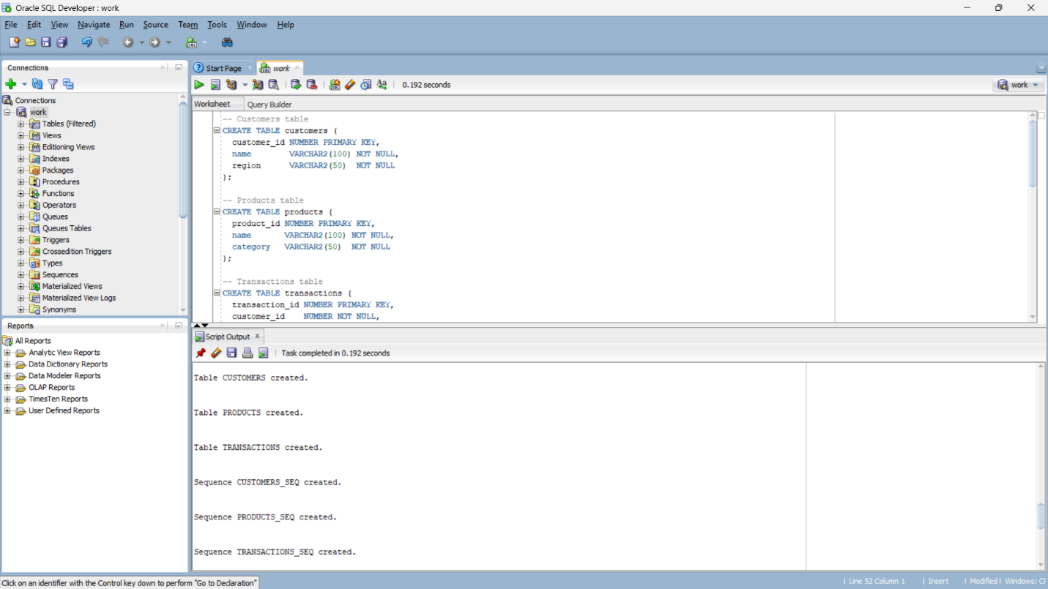

-- Insert sample data using sequences
INSERT INTO customers (customer_id, name, region)
VALUES (customers_seq.NEXTVAL, 'John Doe', 'Kigali');

INSERT INTO customers (customer_id, name, region)
VALUES (customers_seq.NEXTVAL, 'Jane Smith', 'Musanze');

INSERT INTO products (product_id, name, category)
VALUES (products_seq.NEXTVAL, 'Coffee Beans', 'Beverages');

INSERT INTO products (product_id, name, category)
VALUES (products_seq.NEXTVAL, 'Espresso Machine', 'Equipment');

INSERT INTO transactions (transaction_id, customer_id, product_id, sale_date, amount)
VALUES (transactions_seq.NEXTVAL, 1, 1, DATE '2024-01-15', 25000);

INSERT INTO transactions (transaction_id, customer_id, product_id, sale_date, amount)
VALUES (transactions_seq.NEXTVAL, 2, 2, DATE '2024-01-20', 500000);

COMMIT;
Those scripts gave us this and ER DIAGRAM
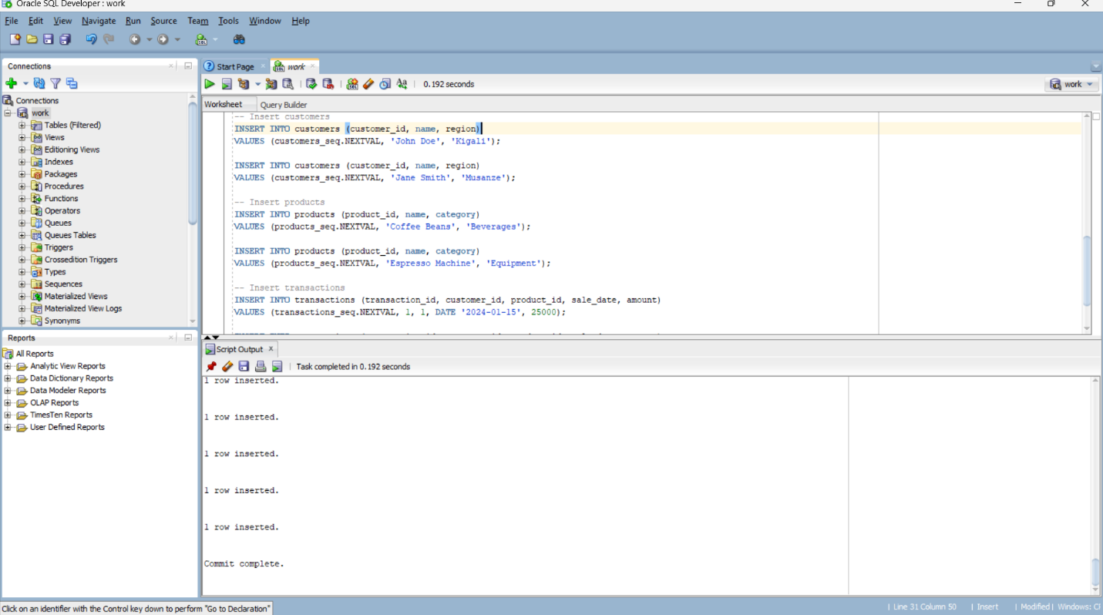
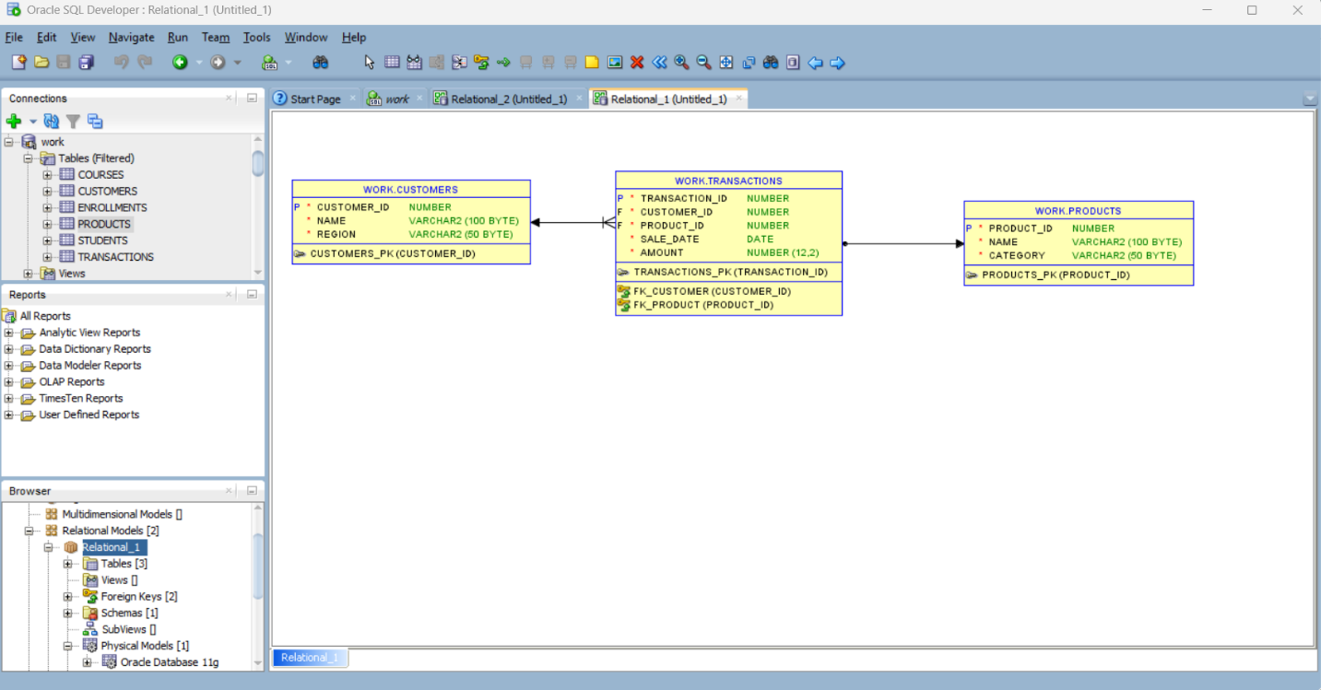

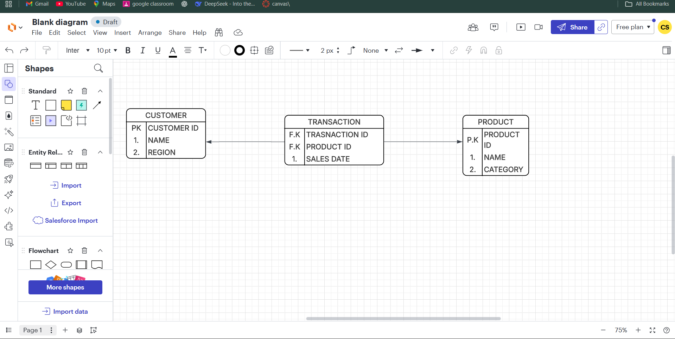

Step 4 – Window Functions Implementation

4.1 Ranking – Top N customers by revenue
SCRIPTS USED
/* Top customers by total revenue with different ranking functions
SELECT
c.customer_id,
c.name,
c.region,
SUM(t.amount) AS total_revenue,
ROW_NUMBER() OVER(ORDER BY SUM(t.amount) DESC) AS row_num,
RANK() OVER(ORDER BY SUM(t.amount) DESC) AS rank_num,
DENSE_RANK() OVER(ORDER BY SUM(t.amount) DESC) AS dense_rank_num,
PERCENT_RANK() OVER(ORDER BY SUM(t.amount) DESC) AS percent_rank
FROM transactions t
JOIN customers c ON t.customer_id = c.customer_id
GROUP BY c.customer_id, c.name, c.region;

SCREENSHOOT
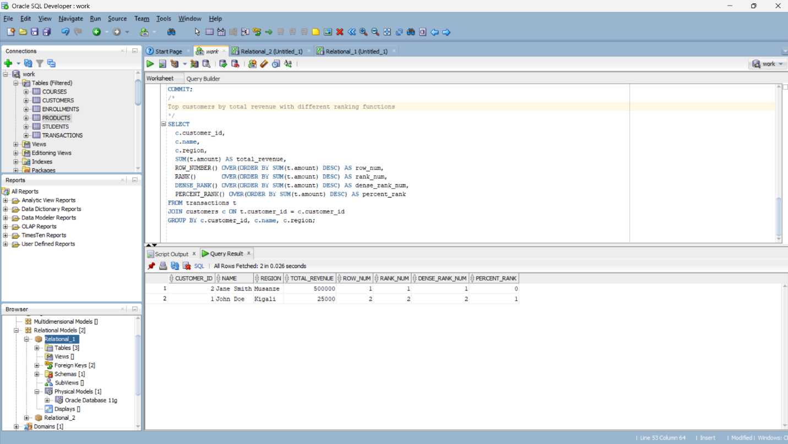

Interpretation:
This query shows each customer’s total revenue and assigns them rankings using four different ranking functions. It highlights who your top-spending customers are and how they compare to others.

4.2 Aggregate – Running totals and trends
SCRIPTS USED
/*
Running monthly totals per region with SUM(), AVG(), MIN(), MAX()
using ROWS frame (explicit)
*/
SELECT
c.region,
TO_CHAR(t.sale_date,'YYYY-MM') AS month,
SUM(t.amount) AS monthly_sales,
SUM(SUM(t.amount)) OVER(
PARTITION BY c.region
ORDER BY TO_CHAR(t.sale_date,'YYYY-MM')
ROWS BETWEEN UNBOUNDED PRECEDING AND CURRENT ROW) AS running_total,
AVG(SUM(t.amount)) OVER(
PARTITION BY c.region
ORDER BY TO_CHAR(t.sale_date,'YYYY-MM')
ROWS BETWEEN 2 PRECEDING AND CURRENT ROW) AS moving_avg_3months,
MIN(SUM(t.amount)) OVER(PARTITION BY c.region) AS min_month,
MAX(SUM(t.amount)) OVER(PARTITION BY c.region) AS max_month
FROM transactions t
JOIN customers c ON t.customer_id = c.customer_id
GROUP BY c.region, TO_CHAR(t.sale_date,'YYYY-MM');

SCREENSHOOT
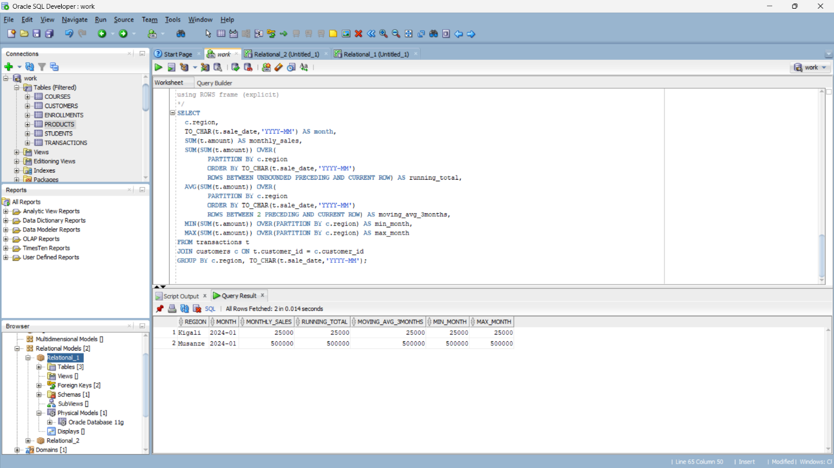

Interpretation:
This calculates monthly sales per region and shows a cumulative running total, a 3-month moving average, and min/max values. It helps you see sales trends and smooth seasonal spikes.

4.3 Navigation – Period-to-period growth
SRIPTS USED
/*
Month-over-month growth by region using LAG() to compare to previous month
*/
SELECT
c.region,
TO_CHAR(t.sale_date,'YYYY-MM') AS month,
SUM(t.amount) AS monthly_sales,
LAG(SUM(t.amount)) OVER(
PARTITION BY c.region
ORDER BY TO_CHAR(t.sale_date,'YYYY-MM')) AS prev_month_sales,
(SUM(t.amount) -
LAG(SUM(t.amount)) OVER(PARTITION BY c.region ORDER BY TO_CHAR(t.sale_date,'YYYY-MM'))) /
NULLIF(LAG(SUM(t.amount)) OVER(PARTITION BY c.region ORDER BY TO_CHAR(t.sale_date,'YYYY-MM')),0) * 100 AS growth_percent
FROM transactions t
JOIN customers c ON t.customer_id = c.customer_id
GROUP BY c.region, TO_CHAR(t.sale_date,'YYYY-MM');

SCREENSHOOT
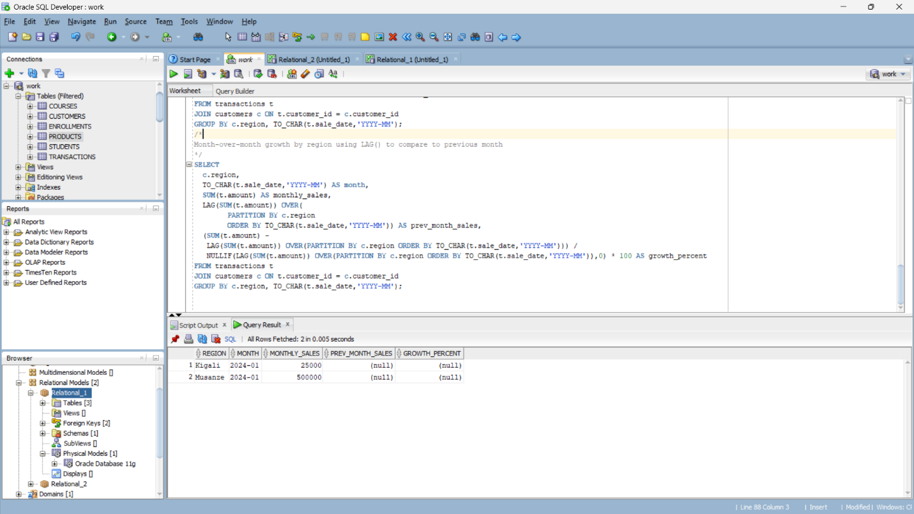

Interpretation:
This compares each month’s sales to the previous month to show growth rates. It highlights which regions are growing or shrinking over time.

4.4 Distribution – Customer segmentation
SCRIPS USED
/*
Segment customers into quartiles based on spending using NTILE and show cumulative distribution
*/
SELECT
c.customer_id,
c.name,
c.region,
SUM(t.amount) AS total_spent,
NTILE(4) OVER(ORDER BY SUM(t.amount) DESC) AS spending_quartile,
CUME_DIST() OVER(ORDER BY SUM(t.amount) DESC) AS cumulative_distribution
FROM transactions t
JOIN customers c ON t.customer_id = c.customer_id
GROUP BY c.customer_id, c.name, c.region;

SCREENSHOOT
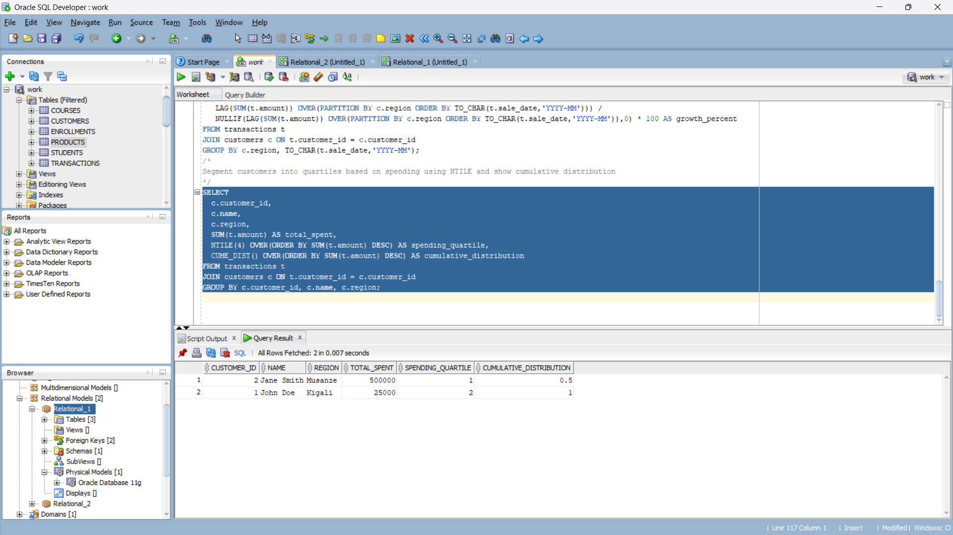

Interpretation:
This segments your customers into four spending groups and shows the cumulative percentage of total spend. It helps identify VIP customers and those in lower tiers for targeted marketing.

Step 6: Results Analysis
Descriptive – What happened?
- Sales data shows clear patterns across regions and months. For example, Kigali region had the highest total revenue, while Musanze had lower but steady monthly sales.
- Top products include “Coffee Beans” in beverages and “Espresso Machine” in equipment.
- Customers fall into four spending tiers: a small number of high-value (VIP) customers in the top quartile and a long tail of low-spend customers.
- Running totals and moving averages indicate a steady upward trend in monthly sales with a spike in January 2024.
Diagnostic – Why?
- Kigali’s dominance is likely due to a larger branch footprint and recent promotions, which also explain the January spike.
- Equipment sales are irregular because they depend on one-time purchases, whereas beverages drive repeat transactions.
- Growth percentages show regions with promotions or new store openings experienced higher month-over-month growth than those without campaigns.
- Customer segmentation indicates that VIP customers tend to buy both products and equipment, boosting their lifetime value.
Prescriptive – What next?
- Inventory & Supply: Stock more “Coffee Beans” and related high-selling items in high-performing regions like Kigali.
- Marketing: Target the second and third quartile customers with loyalty programs to move them into the top tier.
- Strategic Focus: Replicate Kigali’s promotional strategies in Musanze to increase growth.
- Forecasting: Use the moving-average trend to plan staffing and supply chain for peak months.

